ARUBA SMALL FOOTSOOL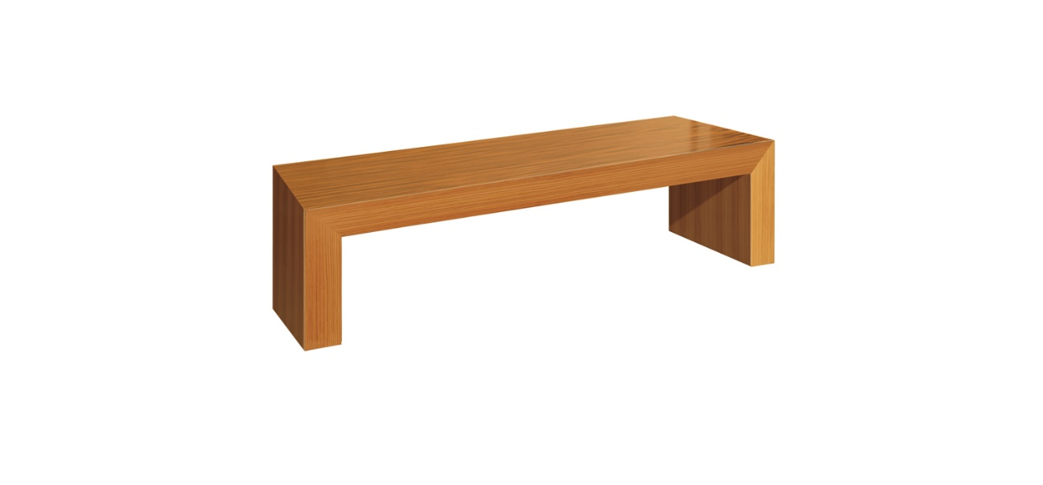
Product description:
Ref. RD-0746-D
Aruba small footsool. Made of ebony wood or cebrano wood.
Sizes:
- 90x45x36H
Finishes:

